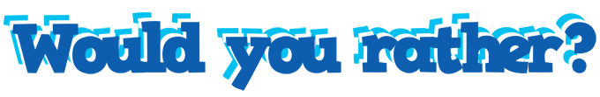
The following is a list of “Would You Rather” statements that you can have students complete almost any time. Start with these or make up your own! You can even ask students to create them.

These can be used as a beginning or ending to a class, a small group mixer or a more structured, full class activity. You decide when they work best!

- Would you rather read a paper book or an ebook?
- Would you rather watch a movie or read a book?
- Would you rather hike or ride a bike?
- Would you rather water ski or snow ski?
- Would you rather travel to the mountains or to a lake cabin?
- Would you rather play sports or participate in a fine art?
- Would you rather sing or play an instrument?
- Would you rather listen to rock or country music?
- Would you rather listen to rap or alternative music?
- Would you rather have a phone or video game system?
- Would you rather take a picture or be in a picture?
- Would you rather write or type your ideas?
- Would you rather go to math class or English class?
- Would you rather work alone or in a group?
- Would you rather talk on the phone or text?
- Would you rather attend class in person or online?
- Would you rather be a lion or a fish?
- Would you rather live in a house or apartment?
- Would you rather live on the beach or in the mountains?
- Would you rather be super fast or super strong?

