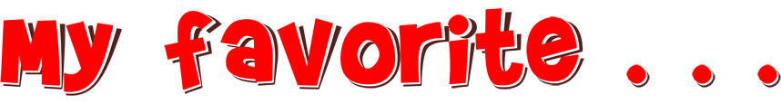
The following is a list of “My favorite . . .” sentence starters that you can have students complete almost any time. Start with these or make up your own! You can even ask students to create them.

These can be used as a beginning or ending to a class, a small group mixer or a more structured, full class activity. You decide when they work best!

- My favorite movie is . . .
- My favorite song is . . .
- My favorite musician or musical group is . . .
- My favorite book is . . .
- My favorite author is . . .
- My favorite travel destination is . . .
- My favorite place to relax is . . .
- My favorite place to study is . . .
- My favorite class is . . .
- My favorite hobby is . . .
- My favorite historical figure is . . .
- My favorite mode of transportation is . . .
- My favorite food is . . .
- My favorite dessert is . . .
- My favorite color is . . .
- My favorite season is . . .
- My favorite holiday is . . .
- My favorite superhero is . . .
- My favorite game is . . .
- My favorite website is . . .
- My favorite time of day is . . .
- My favorite meme is . . .
- My favorite social media platform is . . .
- My favorite emoji is . . .
- My favorite day of the week is . . .

