Accessing AVID OneNote eBinder
One-Pager

To access a template OneNote Package of the AVID eBinder, please follow these steps:
- Create a new eBinder on your institution’s domain or on your desktop.
- Visit the AVID eBinder site at (https://www.avid.org/ebinders)
- Scroll to the bottom of the page and select the Microsoft option. 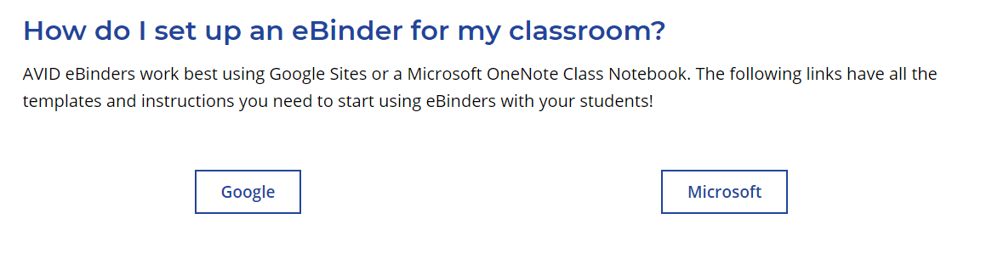
- Watch this short video from AVID DigitalXP, to see how you can engage and copy the AVID OneNote eBinder pages and sections into your existing desktop OneNote eBinder saved on your computer or institution’s domain.
- Watch this short video from AVID DigitalXP, to see how you can interact with the Online OneNote eBinder.
- Have a Mac Computer? No problem, we got you covered here in this short video from AVID DigitalXP.
- As you engage with your OneNote eBinder, you will notice that you can import PDF’s into your AVID eBinder OneNote and annotate using tools within the OneNote menu. Watch this short video to see how you can maximize this feature.

